**IGB381 – Game Engine Technology**

**Workshop 3 (Week 4) – Assignment 1 Preparation**

**Aim:**

To set up the scene for the first Assignment so that content can be completed in a clear and coherent manner

**Objectives:**

* Introduce students to Assignment 1
* Undertake basic Unity operations to set up a basic scene for lighting purposes
* Discuss some theory behind the illumination principles behind the Assignment

**Preparation:**

Please make sure you have completed the workshop tutorials prior to this one as they contain materials and scripts designed for the first Assignment. Also, review the last two Lectures regarding Cg/HLSL code. In addition, it would be beneficial to have read over the Assignment brief and be aware of the marking criteria used.

**Step 1: Assignment 1 Setup**

Create a new Unity 5 project containing a small, flat ground based environment and a controllable avatar with a 3rd person camera attached. You may opt to use the default Unity 3rd Person Character Controller (Ethan) and the ThirdPersonCamera.cs script available on Blackboard alongside the Assignment 1 CRA to save yourself some time. You can Import Ethan by going to Assets->Import Package->Characters. The screenshot below shows you what folders are necessary.

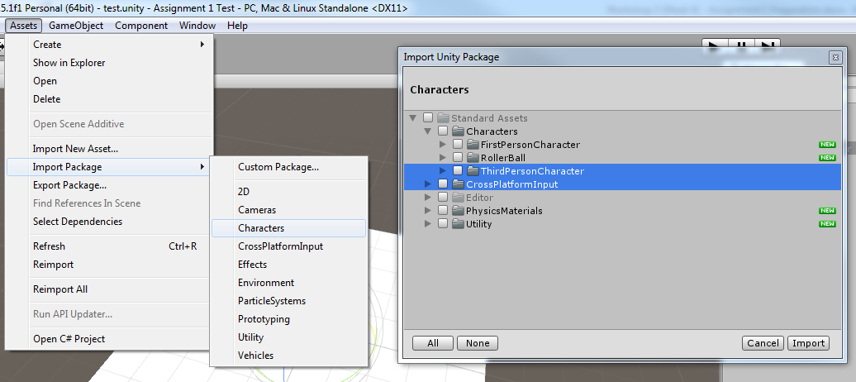

Next, take the original NormalMapping script and shader from last week’s MyFirstProject and apply it to your 3rd person avatar to achieve basic lighting and shading.

Now, set up a directional or point lightsource so that it has the visual effect of the Sun rising in the East and setting in the West. This lightsource should be controlled via a public variable within a script attached to the Sun. Additionally, a GUI control that allows for quick adjustment of the Sun would be appreciated.

Finally, add three simple but varied models to your scene to demonstrate the lighting effects you will implement in the Assignment. These should be small in filesize but geometrically complex enough to provide interesting lighting properties. Attach the NormalMapping script and shader to these object’s materials. You may be required to re-attach their textures.

**Note:** In doing this process you will realise that you may need to make the scripts generic enough to accurately apply textures on objects different from the MyFirstProject. You should modify the NormalMapping scripts to support these features.

**Step 2: Light Source Setup**

Assignment 1 essentially requires you to write a shader that accepts multiple light sources (spotlight and point or directional) to light the scene’s objects accordingly. You will do this primarily by adjusting the existing pixel shader in NormalMapping to account for lighting properties.

To start, first add two spotlights of different size, orientation, direction and colour to your scene, highlighting your objects from various angles.

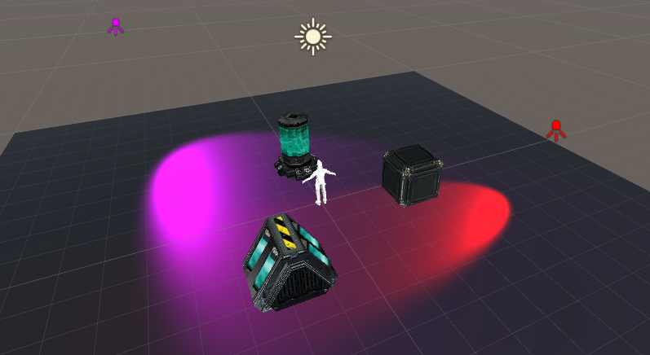

From here on, you will need to figure out how to write the pixel shader methods necessary to effectively light and shade your objects from both the static spotlights and the dynamic directional light. Your workshop tutor will give you some hints and ideas, but this forms the bulk of the assignment and the research you need to perform to complete it.

You should check out the SimpleLighting project as a starting point to guide you with this. Next week’s workshop will also walk through a basic lighting example which should help you understand the theory better.